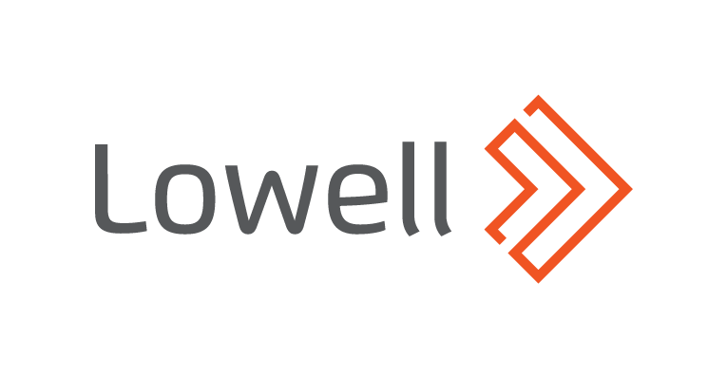
Lowell urges growing number of consumers in problem debt to reach out to access right support
- IPPR Helping Households in Debt report warns young people, ethnic minorities and renters among most at risk of falling into problem debt
- COVID-19 pushing people from ‘just about managing’ into problem debt, with 1 in 7 not being able to pay usual bills
- Lowell is urging those struggling with debts to engage with support and access the right solution to their debt
18th November 2020, Leeds - As the IPPR’s Helping Households in Debt report warns the COVID-19 pandemic is pushing millions into problem debt, Lowell, one of Europe’s largest credit management companies, is urging those struggling with debts to reach out to access support and get on the track to rebuilding their financial health.
John Pears, UK Managing Director at Lowell, said: “Engaging with debt is the first hurdle and letting it pile up can have a hugely detrimental effect on people’s mental health. Getting the right support is vital if people start falling into arrears to make sure debt doesn’t become a problem. This report shows that more people than ever are reaching that tipping point and we have to make sure they seek help and can recover properly, not just get cast aside.
“At Lowell, people can access all sorts of support for their debt with us, getting payment holidays, long term repayment plans or StepChange’s new Covid Payment Plan, all without fees or interest. It is important to us that, now and in the future, we get people back on their feet and financially healthy and stable. We want to ensure that everyone in debt is accessing that flexibility and care, so people need to take the first step and reach out if they are struggling.”
Lowell is headquartered in Leeds with 8m active UK customers and has had a relationship with 1 in 4 UK adults. As one of the largest providers of credit management services in the UK it prides itself on its ethical approach to collections with sustainable and fair outcomes for each individual customer. Lowell charges no interest or fees on debts and provides flexible and long term payment solutions for millions of UK customers.
Media Enquiries
Woolf Thomson Jones, UK Communications Support, +44 (0) 7376 392 693, woolf@montfort.london
About IPPR’s Helping Households in Debt
The IPPR paper, Helping households in debt by Sarah Longlands, Shreya Nanda, Lesley Rankin and Anna Round is available for download at: http://www.ippr.org/research/publications/helping-households-in-debt
About Lowell
Lowell is one of Europe’s largest credit management companies with a mission to make credit work better for all. It operates in the UK, Germany, Austria, Switzerland, Denmark, Norway, Finland, and Sweden.
With its ethical approach to debt management, Lowell always looks for the most appropriate, sustainable and fair outcome for each customer’s specific circumstances. For more information on Lowell, vist our customer website: www.lowell.co.uk
Lowell’s unparalleled combination of data analytics insight and robust risk management provides clients with expert solutions in debt purchasing, third party collections and business process outsourcing.
Lowell was formed in 2015 following the merger of the UK and German market leaders: the Lowell Group and the GFKL Group. In 2018, Lowell completed the acquisition of the Carve-out Business from Intrum, which has market leading positions in the Nordic region. It is backed by global private equity firm Permira and Ontario Teachers’ Pension Plan.
For more information on Lowell, please visit our investor website: www.lowell.com

